

Laxman Dutt Degala | CS5590BD | June 24, 2014

Lab 2 Assignment

**Tasks 1:**

Modifying the existing application and generating a text file with sensor data. Code has been modified and data has been generated.



Uploaded the code to Github.

**Task 2:**

Note: HBase that I used is from my cloudera image.

Push the data to HBase –

1. Create a table
2. Insert the data
3. Retrieve the data.

Required Code changes were done for all the 3 functions. Uploaded the code to Github.

**Create a table:** Table *SensorData2* has been created. Eclipse screenshot:

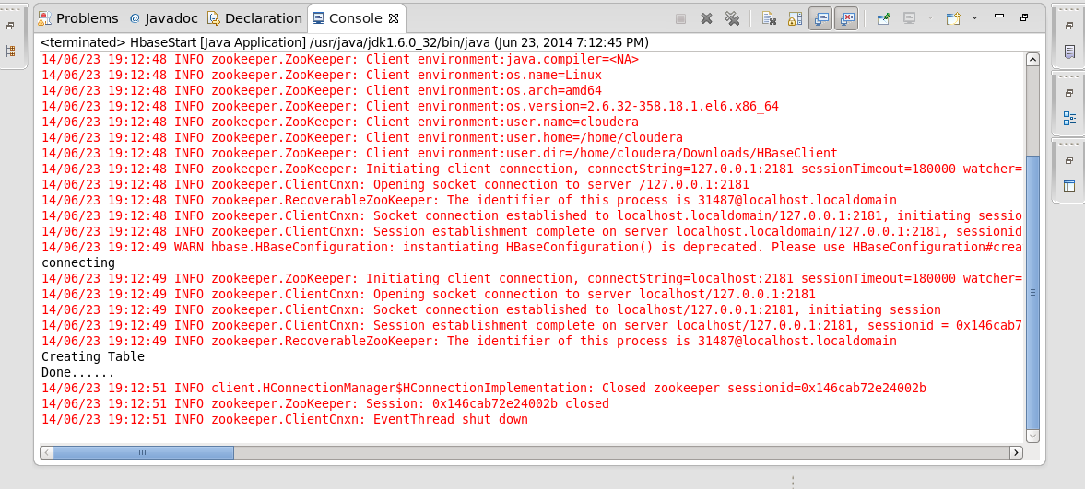

HBASE Screenshot: SensorData2 table has been created. 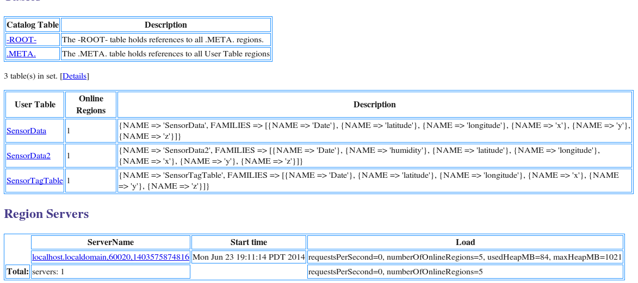

**Insert Data:** Data has been inserted successfully. Please find the snapshot below:

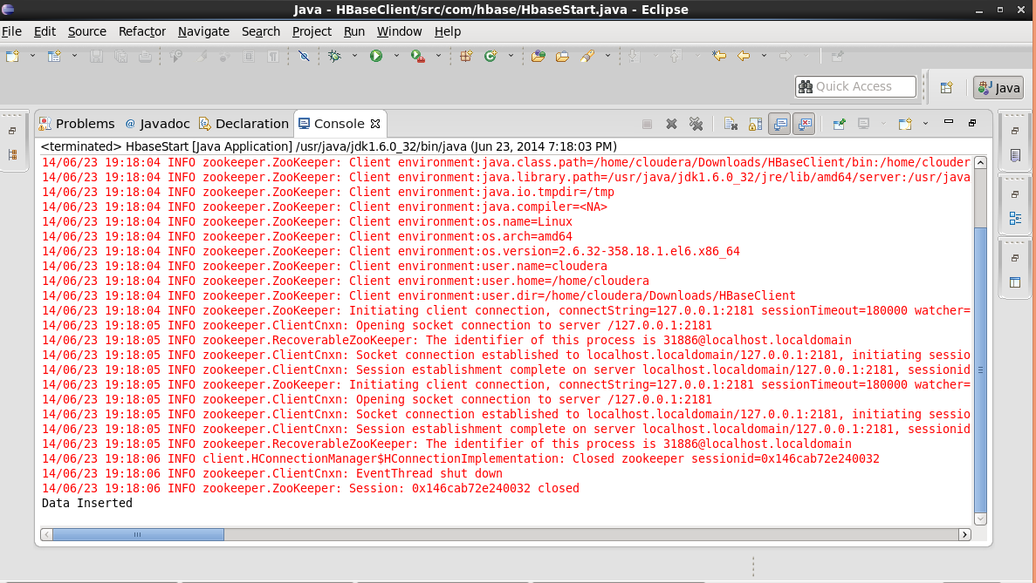

**Data Retrieval:**

Required code changes were done. Please find below the required humidity data apart from the existing data.

Could retrieve latitude/longitude/date/x-y-z coordinates/humidity.

